WineWorks Ltd
Position Description for Assistant Production Manager
(DS & NS Roles)
Location | Hawkes Bay
Department: | Operations
Reports to: | Production Manager
Date of Issue: | May 2025
Working Relationships
Internal: | Production, Cellar, Lab, Warehouse and Engineering Maintenance Teams
External: | Clients & Suppliers
Authority
Spending: | $ as approved by the Production Manager
Staffing: | 3 for DS, 2 for NS
Our Culture
We aspire to a culture where the following values shape our behaviour:
 | Our clients are our life blood. We know that they are why we are here. We work in a flexible and responsive manner to support their operations and meet their individual needs.
 | We do what we say and we’re reliable. We take complete ownership of the process and the tasks that are asked of us. We are committed to go about our job in a straight up way.
 | Passion and pride run deep throughout our organisation. We care for the growth of our colleagues and clients, the safety of our workmates and the environment in which we live.
 | We’re one big team who embrace difference and respect each other regardless of job title. We emphasise the value that comes from working together with one focus.
 | We get things right first time and take no shortcuts. Delivering quality, safe product consistently is our goal. We value expertise and work hard to maintain our high standards.
 | We love to find solutions and believe there’s always a better way to do things. It is this spirit that built the business and will take it to the future.

Organisation Context
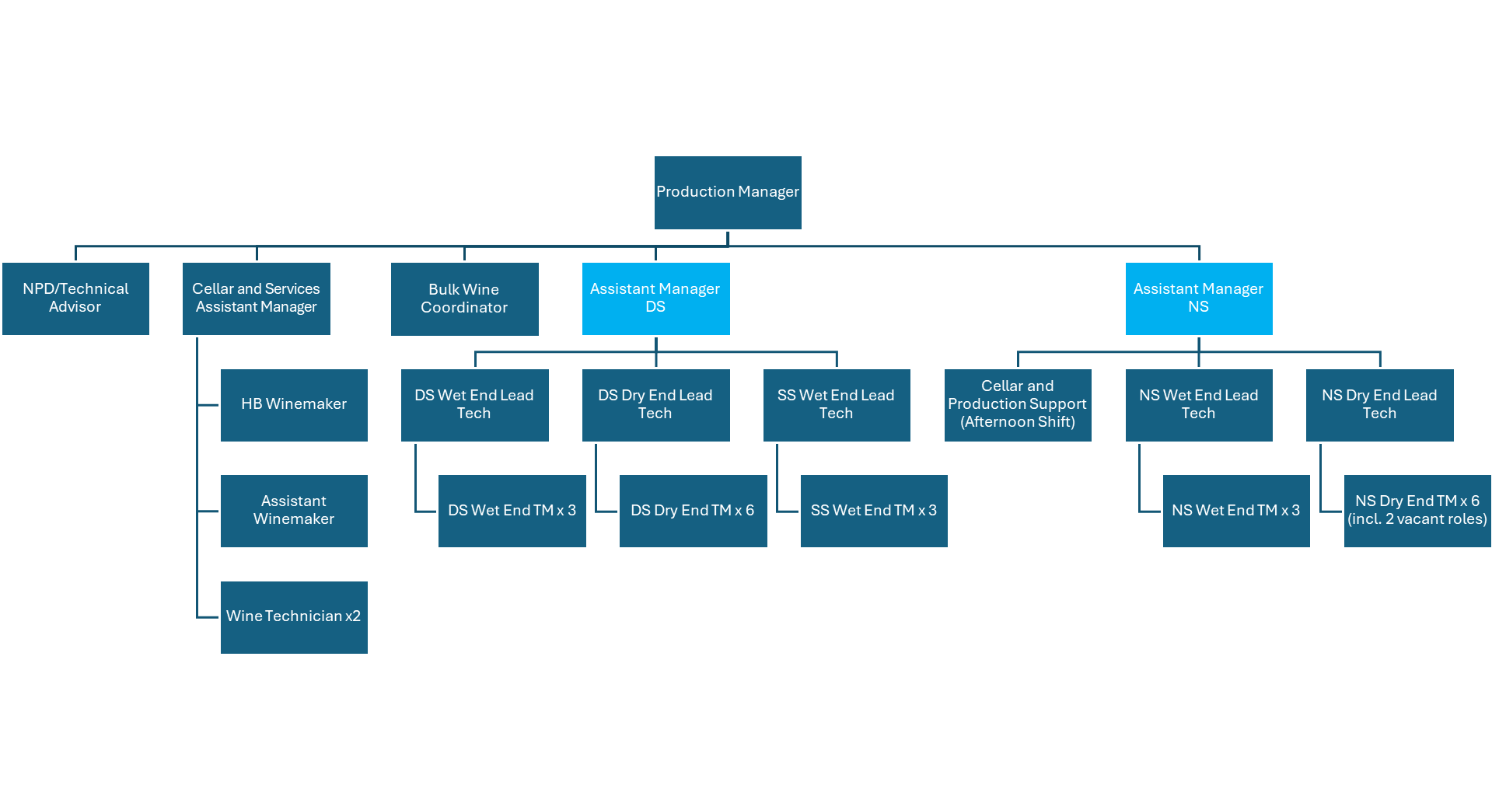
Role Purpose
To support safe, efficient and quality work is completed through the effective leadership of the Night Shift / Day Shift team. This is a key role responsible for the smooth running of all operations throughout the Night / Day Shift, and the communication and escalation of all issues as and when required.

KEY TASK | EXPECTATIONS
Nurtures our Culture | - Champions our culture, promotes & role models the values and behaviours at every opportunity.  - Ensures that all work is undertaken ethically, safely, sustainably and with a quality focus.  - Ensures that their team is adequately trained, resourced and supported to do so.  - Promotes health, safety, sustainability & quality initiatives and seeks continuous improvement.  - Ensures their team follows relevant legislation and certifications, such as BRCGS, so as to meet legal and client requirements.  - Champions and assists in projects to reduce our impact on the environment.  - Is familiar with all relevant policies and procedures that support our Culture and compliance, understanding their roles and responsibilities that are described by these documents.
Recruitment & Induction | - Participate in recruitment processes for new employees joining your team.  - Complete the induction procedure and relevant documentation.  - Ensure there is a training plan prior to start date and follow with regular feedback to ensure understanding and timely progress is achieved.
Manage Performance | - Undertake regular 1:1’s and conduct annual performance reviews.  - Provide feedback, both positive & negative to team members on their performance and/or behaviour.  - Identify opportunities for improvement and ensure relevant support given.  - Make recommendations for pay reviews & recognition.  - Undertake disciplinary or poor performance management (only for misconduct not serious misconduct).  - Provide on-going coaching and encouragement.
Ensure Delivery to Expectation | - Run Toolbox/haka meetings.  - Deliver relevant information to Team Members to support them in their role.  - Delegate work to staff to effectively ensure work is completed on time and to standard.  - Ensure tasks and expectations are understood by team members.  - Undertake relevant checks to ensure quality and safety.  - Assist in developing SOPS as required.
Reporting & Documentation | - Report issues and concerns to manager.  - Maintain data as required and provide KPI information.  - Complete and file reports and documentation.  - Present KPI as required.
Deliver Effective Training | - Ensure sufficient competent team members are available to complete the work.  - Undertake effective induction.  - Provide effective on-job training and cross-training where required.  - Ensure trainers are competent and train to the SOPS.  - Assess team member competence post training.  - Ensure skills matrix is visible, monitored & maintained.  - Ensure all training materials are correct and up-to-date.
Labour Management | - Sign off hours.  - Approve annual leave.  - Prepare and manage Daily rosters
Plant Efficiency | - Look for opportunities to reduce production operating costs.  - Drive plant efficiencies to meet agreed targets.  - Analyse data to identify areas of improvement.  - Implement and maintain Lean principles to reduce or eliminate “Waste”  - Seek year on year improvement in running and change-over performance.
Support to the Production Manager | - Assist Production manager with key on-going projects as identified in the annual business plan.  - Step in as Acting Production Manager when Production Manager is absent. including representing Production at Management Meeting, Company Toolbox and other forums.
Right First Time | - Ensure runs are packaged correctly, on time and right first time.  - Ensure all tools and resources are ready for each run in order that the process runs smoothly.  - Proactively address issues that may affect the team’s ability to deliver right first time.  - Maintain and improve a focus on quality and ensure that team understand that quality is their responsibility.  - Increase quality awareness through use of visual devices throughout the factory.  - Through implementation of 5S ensure plant hygiene is continuously improved
Client Relationships | - Interact with clients professionally.  - Provide proactive, timely and meaningful responses to client’s queries.  - Ensure staff understand the importance of our clients.  - Represent the client’s needs to the team in a way that ensures they clearly understand the client’s expectations.  - Ensure client complains are handled correctly in line with company policy.  - Ensure all client complaints are dealt with in a timely manner.  - Conduct investigations for non-conformances/Customer complaints to ensure they are resolved in a timely manner.  - Take a continuous improvement focus, working with key contacts across the site to put processes in place to prevent future non-conformances/Customer complaints.
Personal Development | - Maintain knowledge of all equipment so that you can effectively operate and train team members on all machines and processes.  - Ensure you remain contemporary in terms of your technical and industry knowledge and capability through research, reading and relevant training and development opportunities.  - Maintain a broad business and commercial perspective.  - Proactively identify methods to utilise this information for the benefit of the business.
Other duties – perform other duties as required | - Flexible & willing to perform a variety of tasks.  - Willingly takes on additional tasks/responsibilities to assist the team and the client.  - Actively participates in matters/meetings affecting the business, their team or their department.

Work Complexity

Accountability | Complexity | People Responsibility | Relating to Others | Expertise
Moderate | Analytical | Leadership & Coaching | Persuading & influencing | Technical
Based upon Strategic Pay SP5 Job Evaluation Methodology

Leadership Competencies
Leading Self | Achieves Results  Holding themselves accountable to meet their commitments | Builds Relationships and Values Difference  Building relationships through communication, valuing difference, and aligning with our values | Being Adaptable  Handling change and looking for better ways of doing things
Leading a Team | Builds Effective Teams  Building teams with a clear purpose that apply their diverse skills and perspectives to achieve common goals | Drives Engagement  Creating a workplace where people are motivated to do their best to help our organisation achieve its objectives | Delegation  Providing direction, delegating, and removing obstacles to get things done.

Skills, Knowledge, and Experience
- 5+ years experience in a manufacturing environment, including leading, training and coaching a Production team is essential.
- Previous Engineering experience/understanding of manufacturing equipment would be an advantage.
- Experience in a “Lean” manufacturing environment is desirable.

