WineWorks Ltd
Position Description Wet End Production Operator
Location | Hawkes Bay
Department: | Production
Reports to: | Production Team Leader
Date of Issue: | Jan 2026
Working Relationships
Internal: | Production Manager, Assistant Production Managers, Production Team Leaders, Wet End Operators, Dry End Operators, Production Forklift Operators, Engineering Team, Inwards Goods Team, Cellar Team
External: | Clients visiting site
Authority
Spending: | $ 0
Staffing: | No.
Our Culture
We aspire to a culture where the following values shape our behaviour:
 | Our clients are our life blood. We know that they are why we are here. We work in a flexible and responsive manner to support their operations and meet their individual needs.
 | We do what we say and we’re reliable. We take complete ownership of the process and the tasks that are asked of us. We are committed to go about our job in a straight up way.
 | Passion and pride run deep throughout our organisation. We care for the growth of our colleagues and clients, the safety of our workmates and the environment in which we live.
 | We’re one big team who embrace difference and respect each other regardless of job title. We emphasise the value that comes from working together with one focus.
 | We get things right first time and take no shortcuts. Delivering quality, safe product consistently is our goal. We value expertise and work hard to maintain our high standards.
 | We love to find solutions and believe there’s always a better way to do things. It is this spirit that built the business and will take it to the future.
Organisation Context
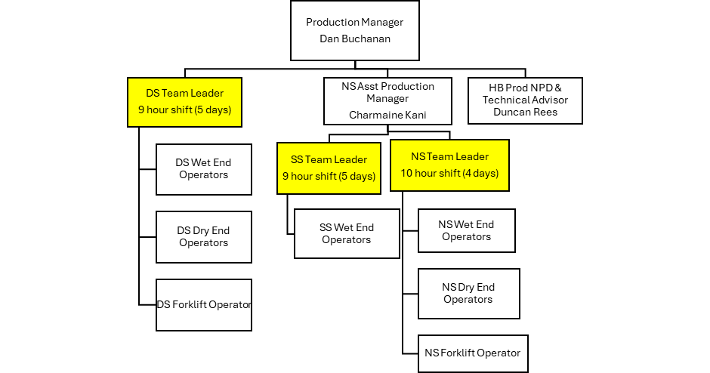
Role Purpose
To consistently produce a high-quality product for human consumption in an efficient and cost-effective manner, meeting or exceeding national and international standards. To operate and maintain all Depalletiser & Fill Room Machinery, working in conjunction with client and internal departments to ensure a safe quality product is produced in accordance with industry standards.-quality product for human consumption in an efficient and cost-effective manner, meeting or exceeding national and international standards
KEY TASK | EXPECTATIONS
Work Productively | - Work closely with the Production Team Leader to ensure your line operates smoothly. This includes rotating and covering machinery operations in Production to complete planned and unplanned activities, including normal operations, unplanned absences, breaks. This may include any machine on which you are trained, including forklift driving  - Follow the instructions of the Team Leader  - Demonstrate full and fair participation in the rotation system for production duties.  - Work collaboratively with others - maintain good relations with all staff members and encourage teamwork  - Maintain the work rates required to maintain steady production.  - Assist with training and development of temporary staff, to make sure they have appropriate skills for their required tasks.  - Follow Broken Glass Policy when broken bottles occur.  - Keep the work area tidy  - Provide feedback and ideas to your Team Leader and/or Production Manager.  - Assist by ensuring targets are achieved or exceeded.  - Inform your Team Leader if any item in production is damaged and Engineering will arrange for it to be fixed.  - Minimize downtime by utilising training opportunities throughout the year.  - Continuously undertake housekeeping duties, as well as GMP (Good Manufacturing Practice) Assist by ensuring targets are achieved or exceeded
Operation and Maintenance | - Safely operate all equipment involved in depalletizing bottles, filling and securing a closure on the product to a high-quality standard.  - Follow and understand the individual Spec Sheet for each run.  - Ensure change overs are as efficient as possible  - Ensure all machinery setups are conducted correctly and in a timely manner, ensuring optimum performance is met producing a safe high-quality product.  - If you cannot achieve this, escalate any issues to your Team Leader.  - Ensure that equipment problems are dealt with in a timely manner and repairs are carried out to a high standard that meet best practice.  - Accurately follow all relevant Standard Operating Procedures.  - Liaise with packaging (Dry) end prior to and during runs to ensure optimal changeover times are achieved to keep to or move ahead of schedule.  - Effectively and consistently minimize downtime.  - Contribute to and use KPI’s to ensure targets are achieved or exceeded.  - To ensure the recording and implementation of every operation, from initiation to completion, is conducted correctly and safely.  - Ensure jobs are staged at the appropriate line ahead of schedule, and all dry goods are returned to stock in the correct fashion.  - Work with the Engineering Department to ensure that the preventative maintenance schedule is carried out.
Follows our Culture | - Champions our culture, promotes & role models the values and behaviours at every opportunity.  - Ensures that their work is undertaken ethically, safely, sustainably and with a quality focus.  - Actively engages in development opportunities to support this.  - Engages in health, safety, sustainability & quality initiatives and seeks continuous improvement.  - Is compliant with relevant legislation and certifications, such as BRCGS, so as to meet legal and client requirements.  - Assists in projects to reduce our impact on the environment. Is familiar with all relevant policies and procedures that support our Culture and compliance, understanding their roles and responsibilities that are described by these documents
Reliability | - Be at work and ready to work 5 minutes before the specified time.  - Communicate all absences to the Team Leader or Production Manager before the start of shift, preferably the day before.  - For smoko and meal breaks, be back at work within the allowed times.  - Government guidelines, which WineWorks adheres to, are 10 minutes for smoko and 30 minutes for meals. The frequency of these in a shift will depend on the length of shift.
Quality Systems | - To be aware that Production is responsible for 100% quality output.  - Ensure that any doubt or concern over the quality of product is raised with the Supervisor or Production Manager.  - Perform quality control checks at start up and hourly thereafter.  - Ensure that all products meet WineWork’s specifications.  - Report dry goods quality issues to your Team Leader
Tanker, Transport, Cellar & Laboratory | - Understand and communicate the bulk wine delivery schedule with the Tanker, Transport,  Cellar and Laboratory.  - Visually sight all tanks and ensure tanker dockets are correct.  - Liaise with the lab to ensure bulk wine is “good to go” before being required for production.
Personal Development |  | - Ensure you remain contemporary in terms of your technical and industry knowledge and capability through research, reading and relevant training and development opportunities.  - Maintain a broad business and commercial perspective.  - Proactively identify methods to utilise this information for the benefit of the business.
Other duties – perform other duties as required |  | - Flexible & willing to perform a variety of tasks.  - Willingly takes on additional tasks/responsibilities to assist the team and the client.  - Actively participates in matters/meetings affecting the business, their team or their department

Work Complexity
Accountability | Complexity | People Responsibility | Relating to Others | Expertise
Process Focussed –Technical Operation | Routine Processes with Existing Solutions – Applies procedures based on-job knowledge | No direct reports | First Level Persuasion | Practical – Significant on -job Expertise
Based upon Strategic Pay SP5 Job Evaluation Methodology
Leadership Competencies
Leading Self | Achieves Results  Holding themselves accountable to meet their commitments | Builds Relationships and Values Difference  Building relationships through communication, valuing difference, and aligning with our values | Being Adaptable  Handling change and looking for better ways of doing things

Skills, Knowledge, and Experience
- Preferable (but not essential) to have filling experience
- Manufacturing experience preferred.
- No formal qualification is required for this role.

